8.21 See sample output

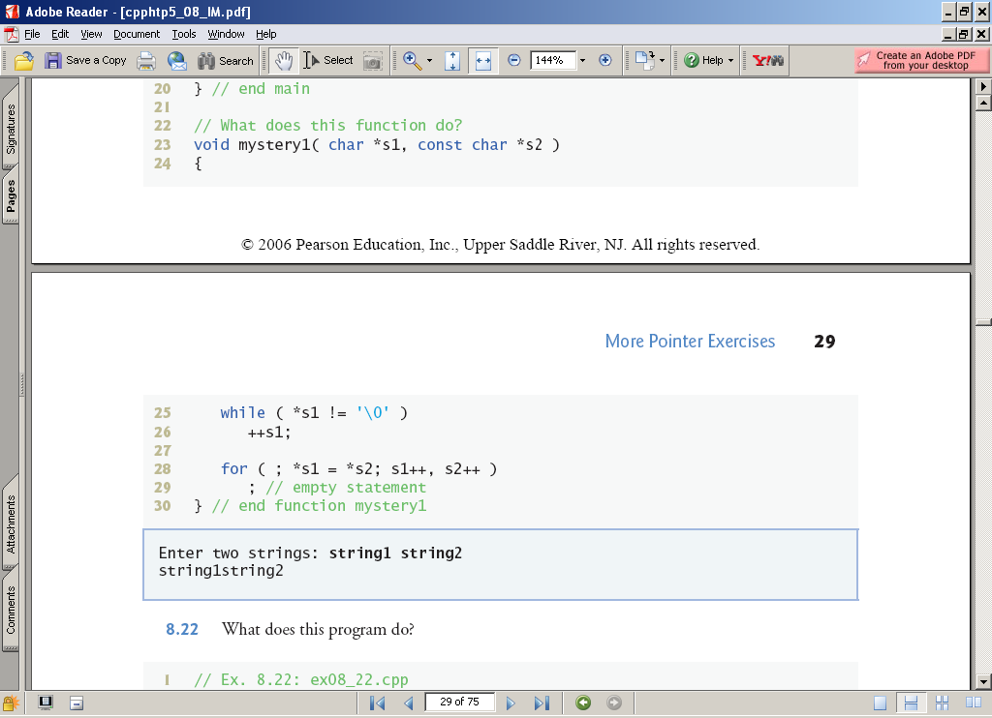

Concatenates the string pointed to by s2 to the end of the string pointed to by s1.

8.22 See sample output

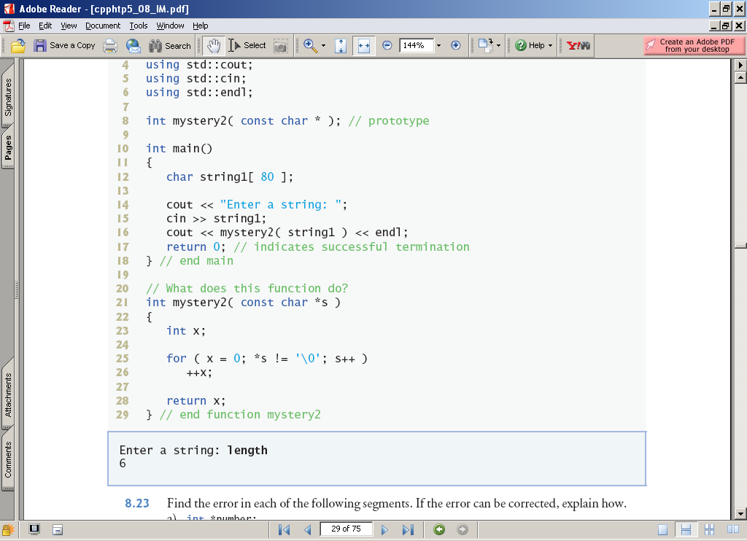

Calculates and returns the length of the string pointed to by s.

8.23

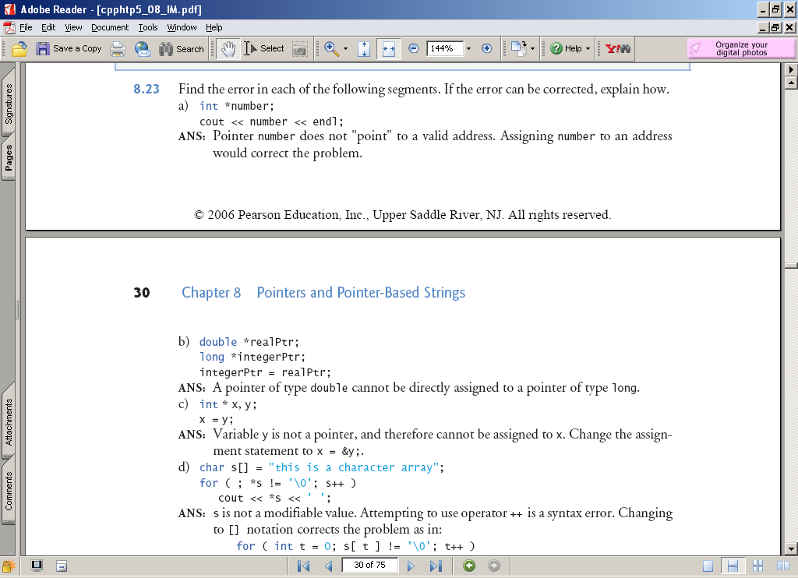

8.23 continued on next page

